I. American Economic System as a Social Problem

A. Monopoly Capitalism

1. multi-national corporations

2. concentration of ownership

3. shared monopolies

4. interlocking directorates

5. “persons” within meaning of the law

6. legal obligation

B. Reasons

1. mergers

2. acquisitions

3. failure to regulate

4. deregulation

C. Power and Monopoly capitalism

1. power over economy

a. deindustrialization

b. r and d, prices

2 power over workers

3. power over communities

4. power over political system

D. Deindustrialization

1. downsizing

2. off shoring

a. GE

b. Wal-Mart

3. outsourcing

4. automation

E. Jobs: Service-based

1. four out of five: McJobs (50% created since “recovery”)

i. part-time

ii. low wage

iii. no benefits/too expensive

iv. no advancement

v. easily replaceable

vi. alienating

vii. emotional labor

2. Temps/contingent employment

i. +400 per cent since 1980s

ii. 40% less per hour

3. Internships

i. unpaid or low income

ii. no guarantee of job

F. Example: San Diego

1. 61% since 2001 less than $25,000

2. mainly in service sector

3. On average, all households lost $2,337 in purchasing power from 2010 to 2011

d. 136,000+ working full-time but w/o health care

G. McDonalds Budget

H. Monopoly Capitalism and Corporate Profits

1. 2001 $503 billion 2008 $1.35 trillion

2. ALL TIME RECORD 2010 $1.68 TRILLION

3. Cash on hand $2 trillion (largest in over fifty years)

4. Fortune 500 2011 all time record $824 billion

5. Taxes

a. 60 % of companies pay no taxes

b. Corp contribution to federal tax revenue: 1950/30% to 2010 8%

c. GE $14.2 billion, $1.1 billion tax benefit

d. 2008-2010 12 lgst corps +$170 billion -1.5% tax rate

e. Deficit Commission recommendation: cut corporate taxes

I. Monopoly Capitalism and deindustrialization are structural reasons for increasing inequality

J. Great Recession

1. Jobs lost (21% low income) and gained (58% low income)

2. Construction is the sector with the most unemployed workers for every available job, while manufacturing has the second-most number of unemployed workers for every available job, belying recent claims of worker shortages in construction and manufacturing. The education and health services sector has the most favorable ratio of unemployed to job openings, but even it has over 80 percent more unemployed workers than job openings. These data show that the main problem in today’s labor market is not a lack of the right workers for the jobs that are available; it’s that employers do not have enough work to be done to need to hire more workers.

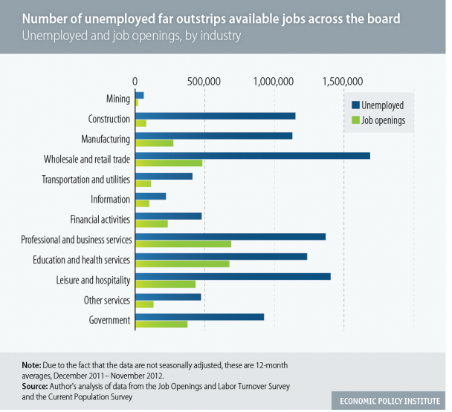

J. *Laissez faire* and “Wealthfare” Capitalism

1. $1 trillion (not country $20 trillion to save “Wall Street”)

2. R and D

a. $72 billion

b. Taxol

c. “clean coal”

3. Tax breaks, loopholes, havens

a. Cruise lines

b. GE 14.2 billion profit, 1.1 billion tax benefit

c. Work opportunity tax credit

4. subsidies: agriculture, nuclear industry

5. environmental and social costs to people

6. bailouts: “too big too fail”

1. weapons and intelligence industries

8. physical, financial, civil and military infrastructruer